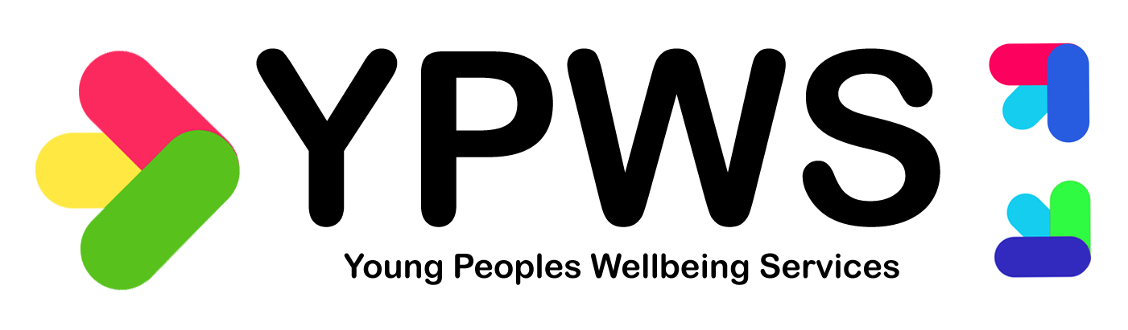
EYCS Counselling Referral Form
Name
Date of Birth
Gender
Address
Postcode
Normal GP Surgery
Name of school/college/Work status
Preferred contact for appointments - mobile text, email, and contact name
Person making referral/ contact details
Counselling methods (between client/counsellor) (tick/click preferred option) | ☐Telephone/FaceTime/Zoom  ☐FACE TO FACE ☐EITHER  Venue preference on Face2Face – tick/click all that apply  ☐Eastleigh ☐Chandlers Ford  ☐Hedge End/Botley ☐ANY
Presenting issues/Reason for referral: (eg Anxiety etc)
Does young person have support from organisations/agencies? If so whom
I agree to EYCS contacting via preferred method? Yes/No | ☐YES  ☐NO
Is young person aware of referral? | yes
If under 16, are parents/carers aware of this referral?
Do any of these apply to the young person (you can tick up to 3 items on the list if applicable) | ☐Autism Spectrum Disorder  ☐Educational Health Plan  ☐Long term illness  ☐Dyslexia/dyspraxia  ☐Sensory impairment  ☐ADHD  ☐Poverty  ☐Neglect  ☐Young Carer  ☐Issues with Education | ☐Pregnant/young parent  ☐Exploitation/abuse  ☐Experiencing discrimination  ☐Armed Forces household  ☐Early Help Hub  ☐Experiencing bullying  ☐Physical disability  ☐Homelessness  ☐Drugs or Alcohol
Are any of these things true for the young person (tick if applicable) | ☐On the Child Protection Register  ☐Deemed Child in Need  ☐Looked after Child
Tick to acknowledge understanding of following: | ☐I understand this is not a crisis service and there will be a waiting list  ☐I understand this is a short-term service and may not be suitable for some young people

Contact details: Email (all will respond): eycounselling@gmail.com; tadic@btinternet.com; 07879761660

EYCS summary:
YPWS Eastleigh Youth Counselling service is available to young people who live in the Eastleigh Borough catchment area and southern parishes. (postcodes SO30, SO31, SO50, SO53, West End SO18). We have counselling venues in Eastleigh (Wells Place Centre), Chandlers Ford (Fryern Pavilion), Hedge End (St Lukes Surgery) and Botley (Botley Health Centre)
We see young people from the ages of 11-19 years
The counselling is funded by various grants and voluntary donations and is completely free to young people. If you wish to donate please see our website and donations can be made via KindLink
We accept self-referrals as well as referrals from schools, GPs, youth workers, agencies etc.
Once a completed referral is received, the young person is put on a Counselling Assessment waiting list – We will aim to arrange an assessment within 4-5 weeks. When an assessment slot becomes available with our counsellors we will be in contact. All young people will have an initial assessment of up to 30 minutes with a trained counsellor and if counselling way forward then a plan will be made for future sessions and young person will be put on our Counselling waiting list for ongoing counselling sessions. If it is felt that counselling is not appropriate, then we will attempt to signpost to alternative services.
All counsellors are members of the British Association of Counselling and Psychotherapy or equivalent.
The nature of our counselling for Young People is that counselling sessions are confidential 1-2-1 sessions between the young person and counsellor. All clients are made aware that if the counsellor has reason to believe that the young person is at risk from harm to themselves or to others, then confidentiality will be broken with the full knowledge of the client at that time.
We hope that parents/guardians will be supportive, but parents/guardians CANNOT take part in the counselling process. Clients who wish their parent/guardian to attend first session (clients choice) then Counsellor will meet with the parent initially, if requested by young person, and in their presence, to discuss confidentiality and for the young person to feel at ease but will not disclose details of any sessions
Counselling sessions are confidential, Counsellors cannot attend meetings or write reports to add to Education plan
Please note that information provided for counselling referral is for the use of YPWS EYCS only and is not available to any other individuals or groups. This means we will not disclose your personal details to another individual or agency without your permission.
We will only contact you by phone or text message and/or email for appointment details (or if Telephone/FaceTime counselling we will ask your consent)
Eastleigh Youth counselling is part of the Young People’s Wellbeing Service Ltd, registered charity no. 1125891.

